Assessment Portfolio
Name: Vejas Sereicikas - P.S. I sent the files in teams chat because it doesn’t fit in assignements Form: 6IEC4
Review questions:
Look at each of the questions below relating to your program and complete your answers in the text
1: Explain the difference between how HTML and CSS are used in creating a web page.
HTML is for all the content on the page. CSS is changing the design of the website page (Color, Font, Etc.)
2: What is the HTML <div> tag used for?
The div tags are used to divide different sections of a page. You can edit individual sections with CSS.
3: Complete the code below to add CSS to make the background of the web page orange.
<html>
<head>
backround-color: #F58216;
</head>
<body>
<p>Welcome to the CSS guide</p>
</body>
</html>
4: What is meant by ‘responsive design’?
That the website changes according to your screen dimensions.
5: How would you change this line of HTML code to make it responsive?
<img src=“moon.jpg” width=750px>
<img src=”moon.jpg width=100% height=auto>
6: Give three guidelines to follow for good website design.
Consistent font, No more than three colors, Easy to read/navigate
7: Give two advantages of using a template in web design.
Because then you can edit off of it and because its hard to think of how your website should look like.
8: Where does the data you enter into a web form go and how might it be used?
The data you enter goes to a database and it could be used for a newsletter list.
Assessment
Basic | Intermediate | Advanced | Expert
I have edited basic HTML to change the content of a web page | I have written basic HTML to create a web page of my own | I have added DIV tags in order to separate areas of a web page | I have added a footer section to a web page
I can change basic CSS to alter the appearance of a web page | I have used basic CSS to control the appearance of my own web page | I have used CSS to control the appearance of DIV sections of HTML
I have specified a width for my web page and images | I have changed the width setting to percentages in order to make the page responsive
I have created more than one web page | I have created links to my other web pages and tested that they work | I have added links to external web pages and tested them
I have used the example web form to submit data to a simulated database | I have added a web form to my own web page

Evidence of my website:
Insert a screenshot using ALT + Print Scrn of your home page below:
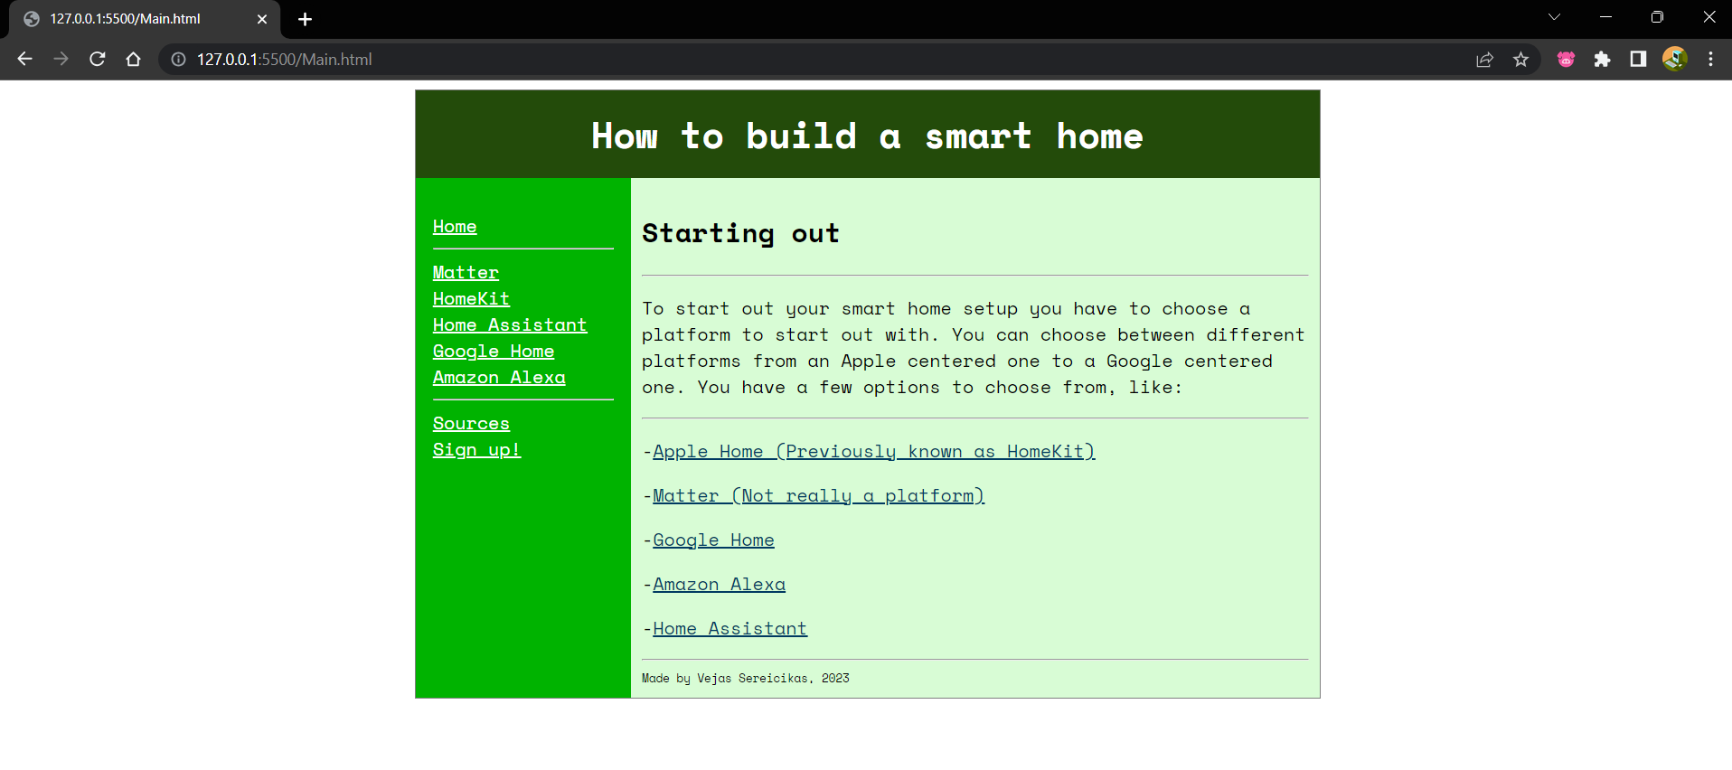
Copy and Paste in the source code for your home page below:
<!DOCTYPE html>
<html>

<!--HTML and CSS template-->

<head>
<style> /*CSS Style definitions start here*/

#container /*Styles for Container*/
{
width:100%;
margin: auto; /*Centres the main container*/
max-width: 800px;
border:1px solid gray;
background-color: #00b300;

}

#header /*Styles for Header*/
{
padding: 15px;
color: #ffffff;
font-family: "Space Mono", monospace;
font-size: 16px;
background-color: #234b0a;

}

#banner
{
padding:0;
margin:0;
text-align:center;
}

#navbar
{
float:left; /*Moves the container to the left*/
width:160px;
height: 200px;
font-family: "Space Mono", monospace;
margin: 0;
padding:15px;

}

#content /*Styles for Main Content area*/
{
margin-left:190px;
padding:10px;
font-family: "Space Mono", monospace;
font-size: 16px;
background-color: #d8fcd5;

}
#footer
{
font-size: 10px;
}

/*Styles for links*/
a:link {color: #ffffff;}
a.blue:link {color: #003961;}
a:visited {color: #ffffff;}
a.blue:visited {color:#003961}
a:hover {color: #000000;}
a:active {color: #ffffff;}

</style>
</head>

<body> <!--Main site content begins here-->
<div id="container"> <!--Page container-->

<div id="header"> <!--Main header-->
<h1 id="banner">How to build a smart home</h1>
</div>

<div id="navbar"> <!--Navigation bar-->
<p>
<nav>
<a href="Main.html" >Home</a> <br>
<hr>
<a href="Matter.html">Matter</a><br>
<a href="HomeKit.html" >HomeKit</a><br>
<a href="Home-Assistant.html" >Home Assistant</a><br>
<a href="GoogleHome.html" >Google Home</a><br>
<a href="AmazonAlexa.html" >Amazon Alexa</a>
<hr>
<a href="Sources.html" >Sources</a><br>
<a href="Form.html" >Sign up!</a>

</nav>
</p>
</div>

<div id="content"> <!--Main content-->
<h2>Starting out</h2>
<hr> <!--Creates a horizontal rule-->
<p>To start out your smart home setup you have to choose a platform to start out with. You can choose between different platforms from an Apple centered one to a Google centered one. You have a few options to choose from, like:</p>
<hr> <!--Creates a horizontal rule-->
<p>-<a href="HomeKit.html" class="blue">Apple Home (Previously known as HomeKit)</a></p>
<p>-<a href="Matter.html" class="blue">Matter (Not really a platform)</a></p> <!--Empty paragraphs-->
<p>-<a href="GoogleHome.html" class="blue">Google Home</a></p>
<p>-<a href="AmazonAlexa.html" class="blue">Amazon Alexa</a></p>
<p>-<a href="HomeAssistant.html" class="blue">Home Assistant</a></p>
<hr>

<div id="footer">
<footer>Made by Vejas Sereicikas, 2023</footer>
</div>

</body>
</html>

